1. 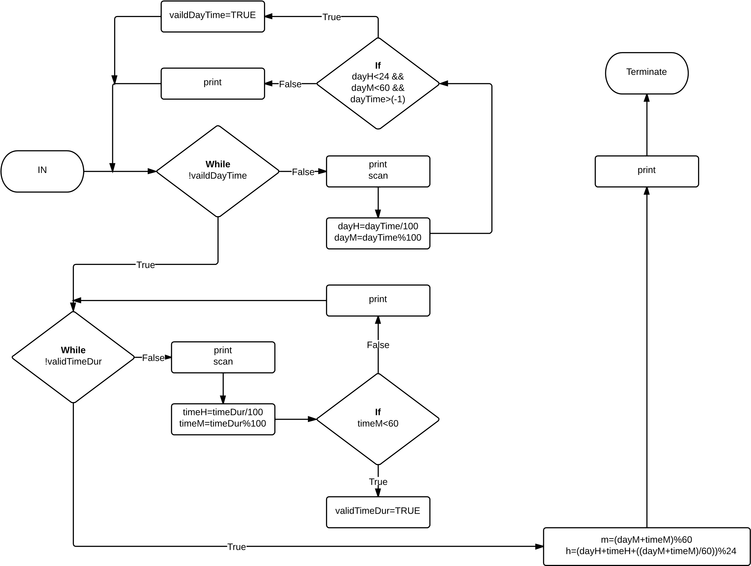  
    **Cases:**
   1. **Case #1**: Day time = 2400, time duration = 0  
       Insert a valid day time (24-hour format): 2400  
       Please enter a valid day time (24-hour format)

Insert a valid day time (24-hour format): …

* 1. **Case #2**: Day time = 2360, time duration = 0

Insert a valid day time (24-hour format): 2360

Please enter a valid day time (24-hour format)

Insert a valid day time (24-hour format): …

* 1. **Case #3**: Day time = 0, time duration = 60

Insert a valid day time (24-hour format): 0

Insert a valid time duration: 60

Please enter a valid time duration.

Insert a valid time duration: …

* 1. **Case #4**: Day time = 0, time duration = 0

Insert a valid day time (24-hour format): 0

Insert a valid time duration: 0

The time is: 0000

* 1. **Case #5**: Day time = 1230, time duration = 30

Insert a valid day time (24-hour format): 1230

Insert a valid time duration: 30

The time is: 1300

* 1. **Case #6**: Day time = 2330, time duration = 30

Insert a valid day time (24-hour format): 2330

Insert a valid time duration: 30

The time is: 0000

* 1. **Case #7**: Day time = 0, time duration = 1234

Insert a valid day time (24-hour format): 0

Insert a valid time duration: 1234

The time is: 1234

* 1. **Case #8**: Day time = 1234, time duration = 1234

Insert a valid day time (24-hour format): 1234

Insert a valid time duration: 1234

The time is: 0108

1. 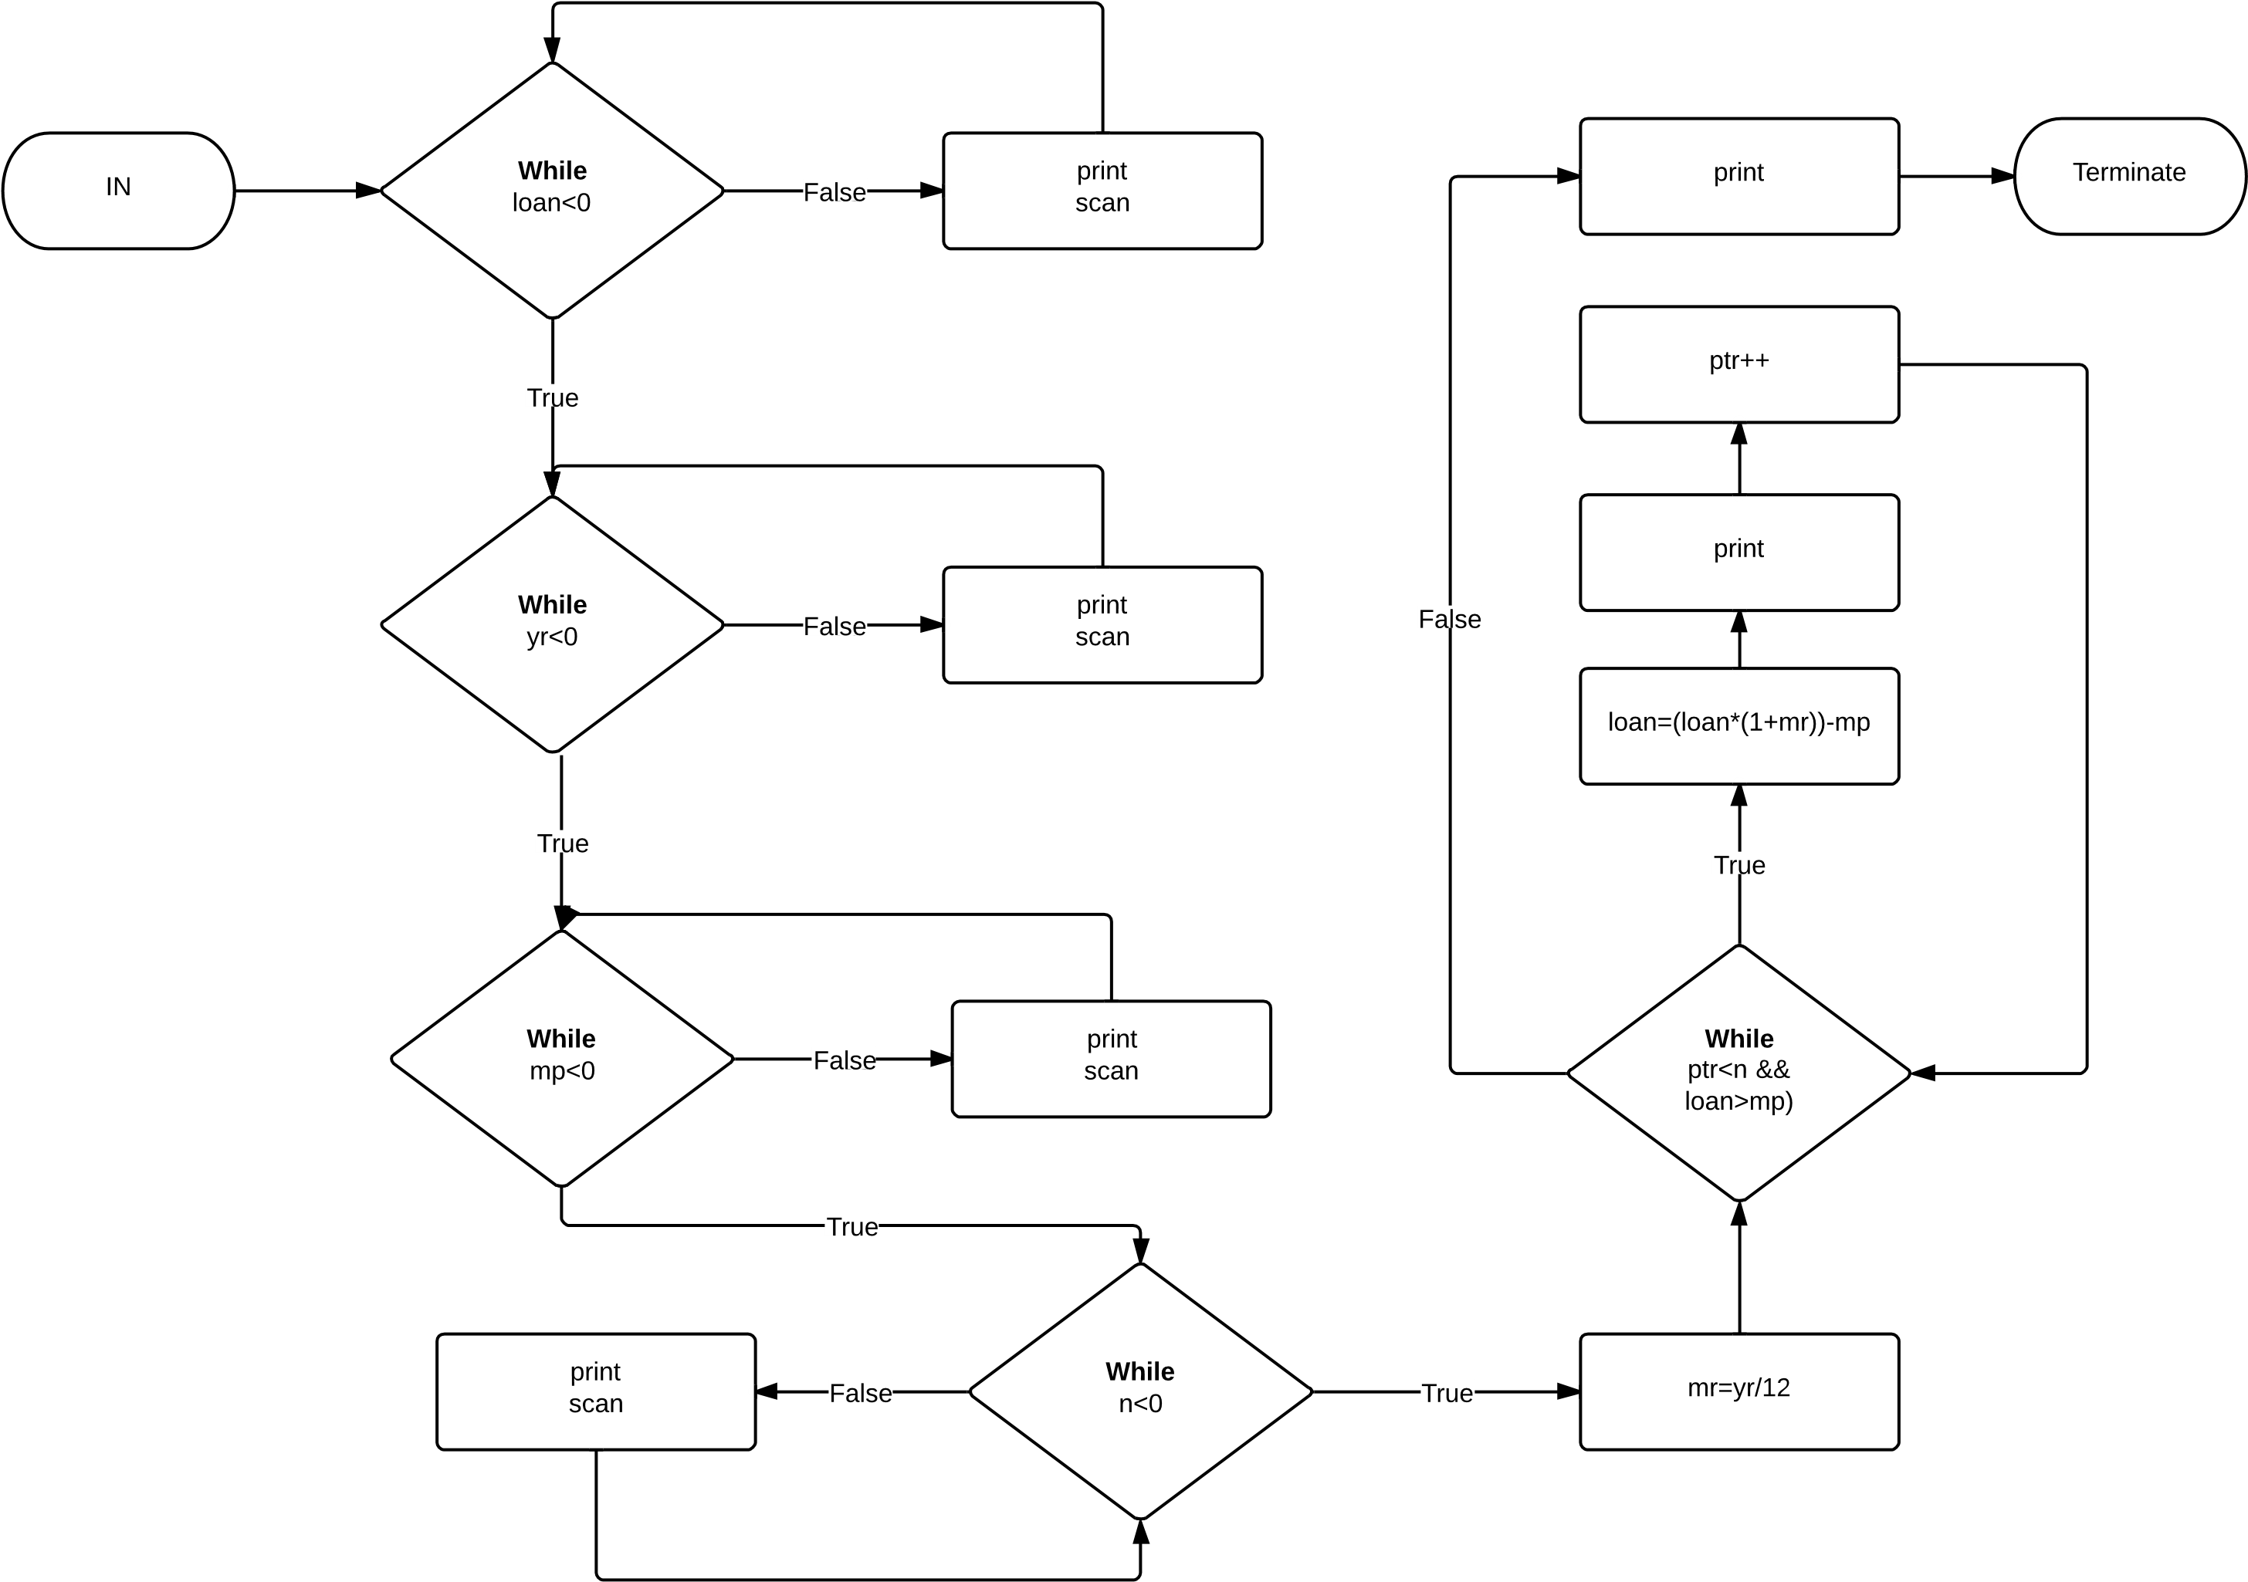  
   **Cases:**
   1. **Case #1**: loan=-1

Please enter the amount of loan: -1

Please enter the amount of loan: …

* 1. **Case #2:** loan=1000, yearly rate: -1

Please enter the amount of loan: 1000

Please enter the yearly interest rate: -1

Please enter the yearly interest rate: …

* 1. **Case #3**: loan=1000, yearly rate: 0.12, monthly payment=-1

Please enter the amount of loan: 1000

Please enter the yearly interest rate: 0.12

Please enter the monthly payment amount: -1

Please enter the monthly payment amount: …

* 1. **Case #4:** loan=1000, yearly rate: 0.12, monthly payment=100, n=-1

Please enter the amount of loan: 1000

Please enter the yearly interest rate: 0.12

Please enter the monthly payment amount: 100

Please enter the number of monthly payments: -1

Please enter the number of monthly payments: …

* 1. **Case #5:** loan=1000, yearly rate: 0.12, monthly payment=100, n=3

Please enter the amount of loan: 1000

Please enter the yearly interest rate: 0.12

Please enter the monthly payment amount: 100

Please enter the number of monthly payments: 3

The loan balance is: 910.00

The loan balance is: 819.10

The loan balance is: 727.29

The last payment is: 727.29

* 1. **Case #6**: loan=100, yearly rate: 0.1, monthly payment=50, n=10

Please enter the amount of loan: 100

Please enter the yearly interest rate: 0.1

Please enter the monthly payment amount: 50

Please enter the number of monthly payments: 10

The loan balance is: 50.83

The loan balance is: 1.26

The last payment is: 1.26

**Questions**:

1. **Question #1**: loan=100000, yearly rate: 0.1, monthly payment=10000, n=10

Please enter the amount of loan: 100000  
Please enter the yearly interest rate: 0.1  
Please enter the monthly payment amount: 10000  
Please enter the number of monthly payments: 10  
The loan balance is: 90833.34  
The loan balance is: 81590.28  
The loan balance is: 72270.20  
The loan balance is: 62872.45  
The loan balance is: 53396.39  
The loan balance is: 43841.36  
The loan balance is: 34206.70  
The loan balance is: 24491.76  
The loan balance is: 14695.86  
The loan balance is: 4818.32  
The last payment is: 4818.32

1. If the monthly payment was 15,000 then the monthly payments will be less than 10, therefore, the program will only produce 6 outputs because the last payment is less than 15000. On the contrary, if the monthly payment was 750, then the monthly payments will be more than 10, therefore, the program will only produce 10 outcomes and the loan will not be paid by the end of the 10 months. Since this number is less than 10% of the loan sum, the loan will actually increase because of the 10% interest.
2. 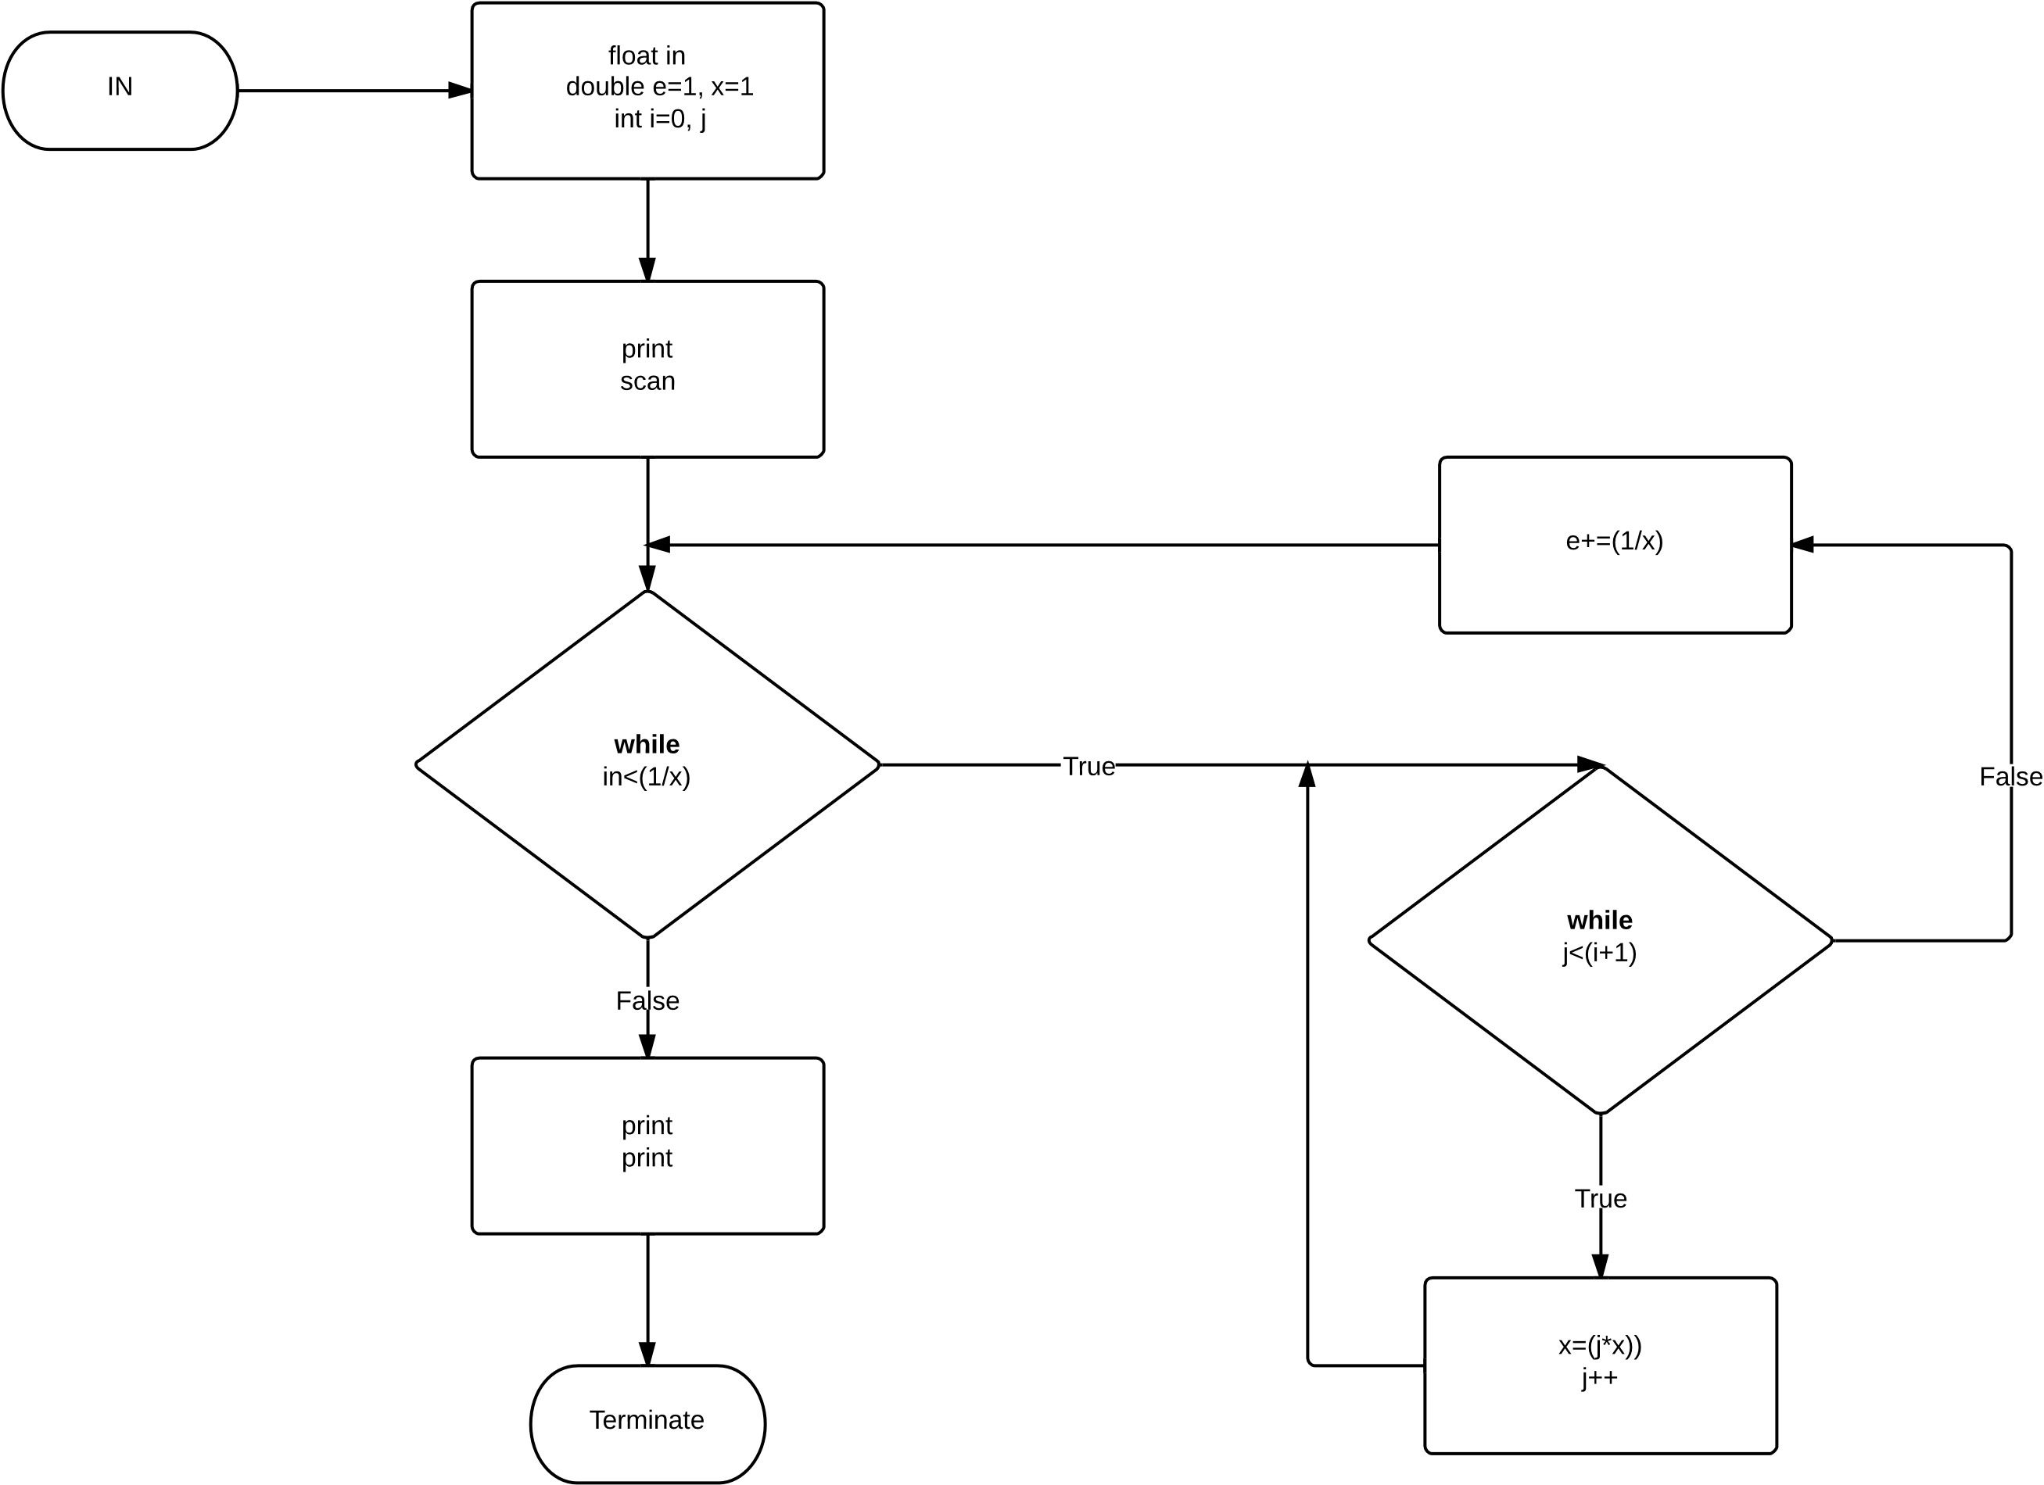  
   **Cases:**
   1. **Case #1:** 0.1

The approximate e value is: 2.70833333333333303727

The number of terms required to generate e was 5

* 1. **Case #2:** 0.01

The approximate e value is: 2.71666666666666634100

The number of terms required to generate e was 6

* 1. **Case #3:** 0.001

The approximate e value is: 2.71825396825396836675

The number of terms required to generate e was 8

* 1. **Case #4:** 0.0001

The approximate e value is: 2.71827876984127003723

The number of terms required to generate e was 9

* 1. **Case #5:** 0.00001

The approximate e value is: 2.71828152557319224769

The number of terms required to generate e was 10

* 1. **Case #6:** 0.000001

The approximate e value is: 2.71828180114638451315

The number of terms required to generate e was 11

* 1. **Case #7**: 0.0000001

The approximate e value is: 2.71828182619849290091

The number of terms required to generate e was 12

* 1. **Case #8**: 0.00000001

The approximate e value is: 2.71828182828616871092

The number of terms required to generate e was 13

* 1. **Case #9:** 0.000000001

The approximate e value is: 2.71828182844675936281

The number of terms required to generate e was 14

* 1. **Case #10:** 0.0000000001

The approximate e value is: 2.71828182845823018710

The number of terms required to generate e was 15